URL: <http://www.belhouleuropean.com/html/home.htm>

Belhoul European Hospital was established in 1996 as the first day care hospital in the UAE providing comprehensive medical facilities through its 19 outpatient clinics. The operating theatre and diagnostic department is supported by an accomplished team of highly qualified, specialized doctors world wide.

**Integration**   
Belhoul European Hospital is a collection of medical specialties, simultaneously offering advanced diagnostic technology and outstanding service.   
  
**Comprehensive**   
We provide over 19 clinics of specialist expertise under one roof to deliver the highest level of care to our patients.

**Support services:**

ENAYA home nursing services unit

Laboratory

Radiology

Pharmacy

Insurances

Physiotherapy

**Services:**

Cardiology

Dental

Dermatology

ENT

Gastroenterology

General laparoscopic surgery

General practice

Inpatient

Internal medicine and endocrinology

Gynecology

Ophthalmology

Orthopedic surgery

Pediatric

Plastic surgery

Psychiatry

Pediatric surgery

Urology

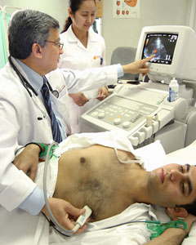

**Doctor credentials:**

**Dr. Mohammad Motaweh**  
**Specialist Cardiologist**

I am Dr. Mohammad Motaweh, I am 57 years old, I graduated from the medical school in Cairo in 1972, and since then practicing medicine nonstop.   
  
I have the following qualifications: a Bachelor of Medicine and surgery 1972, Diploma of Internal Medicine 1975, Master of Cardiology 1977, and Doctorate of Cardiology 1984.   
  
Currently I am working as Specialist Cardiologist in Belhoul European Hospital and still registered as a Professor of Cardiology in Al-Azhar University.   
I have gained my experience from working in the university hospitals of Al-Azhar University Cairo, Germany, USA, Saudi Arabia and UAE.   
My areas of interest are general cardiology and non-invasive cardiology, mainly echocardiography and nuclear cardiology

**Doctor in dental**

**Dr. May A. Mahdi**  
**Dental Surgeon**

Dr. May A. Mahdi qualified at The University of Gotenburg, Sweden with a Bachelor in Dental Surgery and Diploma in Root Canal treatment.  
  
With a total of 20 years work experience in many countries including Sweden and the UAE, Dr. Mahdi joined Belhoul European Hospital in 1999 where she performs all types of dental treatments for Children and Adults.  
  
Dr. Mahdi is particularly interested in cosmetic dentistry such as porcelain veneer, whitening, crowns and bridges.  
"My duty is to ensure a healthy and beautiful smile for my patients"

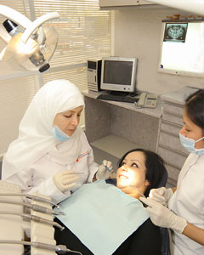

**Doctor in ENT**

**Dr. Michel C. Szalay**  
**Ear, Nose and Throat Specialist (ENT)**

Dr. Michel C. Szalay**,** M.D., FRCS Ed., comes from France and is an ENT Specialist, Head & Neck Surgeon, and Specialist for Aviation Medicine.   
Dr. Szalay is registered as a Specialist with the French medical board and is a Fellow of the Royal College of Surgeons Ed UK.   
Having enjoyed a long career as a Consultant in the department of ENT and Head & Neck Surgery in La Pitiè-Salpetrière University Hospital Paris-France, Dr. Szalay came to Dubai in May 1996 to join Belhoul European Hospital.

**Doctor in gastroenterology**

**Dr. Anand Nathwani**  
**Specialist Gastroenterologist,**  
**Hepatologist& Endoscopist**

My name in Dr. Anand Nathwani, M.D, A.S.G.E (USA). After completing my Boards in Internal Medicine from University of Mumbai, I obtained my training in Gastroenterology and Endoscopy as a Fellow at the Cook County Hospital Chicago (USA) and University of California Los Angeles (UCLA). I have been visiting the Belhoul European Hospital for over a decade now as a Visiting Consultant Gastroenterologist. I was a Visiting Consultant Gastroenterologist at Dubai Public Hospitals in 1977-78 and at Doha-Qatar in 1981-82. Being a Mumbai based Gastroenterologist I am attached to some Hospitals there, and have pioneered several endoscopy procedures like OGD Scopy, Colonoscopy, Polypectomy, Ileoscopy, Jejunoscopy, ERCP, Sphincterotomy, Stent Placement and Sclerotherapy at these hospitals. So far I have performed more than 35,000 procedures

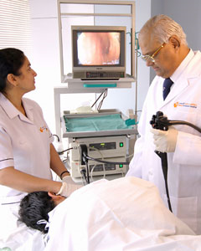

**Doctor in endocrinology**

Dr.Nagwa Khalil Akasha  
Internist & Endocrinologist

* M.BB.B.CGH Ain shams university Egypt
* MRCP Ireland
* MRCP 1st UK
* MRCP 2nd UK
* CIDC UK
* Endocrinology tutor Dubai medical college
* Winner of the award of service excellence DOHMS Sep 2006
* Member of emirates medical association
* Member of European endocrinology society

**Doctor in gynecology**

**Dr. Galia Kalotova**  
**Specialist Obstetrician & Gynaecologist**

Dr. Galia Kalatova, is a Obstetrics and Gynecology Specialist. Graduating as an MD from The Medical Academy of Bulgaria, Dr. Kalatova went on to Specialise at The National Institute of OBS/GYNAE – Medical Academy Sophia.  
  
Dr. Kalatova worked as a Specialist in two large hospitals, both members of FIGO, where she followed the International Guidelines in OBS-GYNAE treatment.  
  
With a total of 16 years as a specialist experienced in all OBS-GYNAE procedures, Major and Minor Surgeries, Ultrasound Diagnosis, Managing Normal and Abnormal Labour, experienced in Diagnostic Laparoscopy and Colposcopy, Dr. Kalatova now works at Belhoul European Hospital for more than 8 years.

Doctor in ophthalmology

**Dr. Samir Jamal**  
**Specialist Ophthalmologist Surgeon**

Dr. Samir Jamal (MD, CES, AES France), Ophthalmologist at Belhoul European Hospital, graduated from Damas University College of Medicine (MD) going on to obtain a medical degree from University Lyon II, Claude Bernard, France. Dr. Samir completed a residency in CHU Hospital E-herriot and a fellowship at The University Lyon II.   
  
Fields of interest are: microsurgery of the AS (glaucoma, cataract, cornea), Strabismus specialist, eye and lid plastic and reconstructive surgery, pediatric ophthalmology and contactology.   
  
Dr. Samir is also academically active as an Associate Clinical Professor of Ophthalmology University of TICH – SAR.

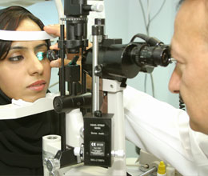

**Doctor in orthopedic**

Dr.Tabet Al Sadek  
BM, MD, DM,  
Specialist Orthopedic Surgeon

Areas of interest:

* All kinds of trauma (Fractures)- sports injury
* Pediatric Orthopedic diseases:
* DDH developmental dislocation of the hips, joints
* Club feet
* Malformation disease in children
* Bow legs

Arthroscopic procedures

* Total hip replacement (THR)
* Total knee replacement (TKR)
* High Tibial osteotomy for the knee osteoarthrosis
* Low Back pain
* Osteoporosis

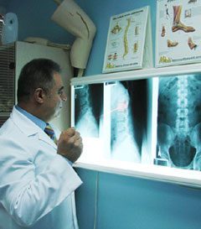

**Doctor in pediatric**

**Dr. Mohamed Ahmed Al- Khojai**  
**Specialist Pediatrician**

My name is Dr. Mohamed Ahmed Al- Khojai, I am a Specialist Pediatrician.  
  
I graduated with a bachelor degree of Medicine from Alexandria University, then specialized in Pediatric Alexandria University and Royal College of physicians United Kingdom.  
  
I worked in all fields of Pediatrics in the department of health since 1974, Developed main interest in community Pediatrics, Pediatrics nephrology and Pediatrics Paleontology

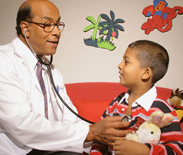

Doctor in urology

**DR Dawood Mohammed Kashmoula**  
**Specialist – Urologist**  
**M.B.Ch.B-Baghdad, F.I.C.M.S- Urology**

Specialist in treating and doing various procedure and surgery for all urological and genital problems , doing lithotripsy for stones in urinary system, treating male sexual and fertility problems and treating prostatic diseases .

**Contact us**

Phone : 971 4 345 4000 or 345 7500

Fax : 971 4 345 7052

PO Box : 4674, Dubai, UAE

Emai : [beh@belhouleuropean.com](mailto:beh@belhouleuropean.com)

Website : [www.belhouleuropean.com](http://www.belhouleuropean.com)